**CMPE 131 Software Engineering**

**Moo Project**

Detailed Software Requirements

Paul Diaz

Stefan Francisco

Timothy Magallanes

Tyler Olson

**Project Description**

After downloading the Moo application, a user has to create a free Moo account in order to write movie or trailer reviews in addition to “liking” someone else’s review. Users can write a review of either the film or trailer they just watched and publicly publish the review so other users are able to read their reviews. Other users will have the ability to “like” the reviews, thus endorsing them. Writing reviews is incentivized; the more reviews written, the more Moo points users accumulate to eventually turn into redeemable points for movie tickets and movie theater concessions. Furthermore, the more “likes” a user receives from other users for the review written, the more Moo points the user earns for the aforementioned prizes. User accounts are simple and concise; usernames created have to follow strict guidelines deemed publicly acceptable by Moo. Users may choose to have their personal information and avatar publicly displayed on their profile or kept private. All of this is easily set-up during the registration process once the application has been downloaded.

**List of Software Requirements**

1. **Installation**
2. **Registration**
3. **Login**
4. **View Profile**
5. **Browse Movies**
6. **Watch Trailer**
7. **Critique a Movie**
8. **Critique a Movie Trailer**
9. **Leaderboard**
10. **Redeem Points**

**Description of Software Requirements**

1. **Installation**
   1. Install: Users must go to their respective application store to download Moo (App Store, Play Store, etc). Moo application costs $10 per account.
   2. Access: To install Moo, user must allow Moo to access their identity, camera, microphone, and location services in order to provide a seamless interaction between the user and application.
2. **Registration**
   1. Age Limitation: To register for the application, user must be at least 13 years of age. Additionally, to register, user must input their birthday to complete registration.
   2. Verification: A verified email address and password is required to register for Moo.
   3. EULA: User must accept Terms and Conditions (EULA - End-User License Agreement) to be able to register for Moo.
   4. Username: User must create a special, unique username in accordance with (IAW) Moo terms of service (TOS) that is appropriate (no vulgar or offensive names) and is unique to the specific user; no two usernames will be alike.
   5. Personal Information: User will input their first and last name.
      1. Moo will store personal information and maintain the integrity and privacy of the user; information will not be publicly shared.
      2. User will be allowed to upload a picture or choose a default avatar as their own avatar. Additionally, user can choose to have this publicly displayed when posting comments/reviews, or have it private. In the event the user chooses to have their avatar set to private, a default Moo logo will be used on all comments/reviews.
3. **Login**
   1. First Login: On first login, user must enter email and password.
      1. Moo will remember the user login credentials upon every launch of the application, unless user prompts to sign out.
   2. Forgotten Password and/or Username: “Forgot password or username?” text link is provided for registered users who forgot their password and/or username. Moo will send a confirmation email to the user’s predetermined email; user will then be required to change their password in the event they forgot their password, or they will receive their forgotten username.
4. **View Profile**
   1. User Profile: A default user profile shows basic information of the user.
      1. Name, age, list of movies reviewed, total number of likes for each movie, total number of likes for each movie have reviewed, location (city and state), and total number of Moo points accumulated.
      2. User can choose to hide any information mentioned in 4(ai).
   2. Profile Edit: User can edit their profile to change their name, age, username, and personal avatar. Additionally, user can choose what can be viewed publicly, or set certain profile aspects to private.
   3. Information Restrictions: Certain information given by the user to the application upon registration will not be shown to other users:
      1. Full name, email address, and location information will not be accessible to other users.
5. **Browse Movies**
   1. A list of current movies that are out in selected theatres that have collaborated and agreed on a partnership with Moo will be displayed on a specific page.
      1. The user has the option to review the movie, write a comment, and endorse the movie by giving it a thumbs up, or giving the movie a thumbs down.
      2. Upon each click of the movie, user can see a list of actors, movie length, Motion Picture Association of America (MPAA) rating (G, PG, PG-13, etc.), a list of user reviews, and how many users have endorsed the movie or expressed disinterested by giving it a thumbs up or thumbs down, respectively.
6. **Watch Trailer**
   1. Users can pick and choose movie trailers in theaters to watch.
      1. A brief text summary of the movie will be provided below the video screen for users to read.
7. **Critique a Movie**
   1. Prior to Writing a Movie Review:
      1. Application will prompt user to write a review if location information of user shows they are currently within a short proximity of a movie theater.
      2. Quick notes can be generated and saved via voice to generate quick comments to add to user's future in-depth review.
   2. Writing a Movie Review:
      1. User can generate a movie review that will be seen by all registered users of Moo.
      2. To rate the movie, user will select how many stars to accompany the movie review. User can choose between one and five stars. One star denotes a negative review, five stars denotes an outstanding movie.
   3. Interaction with Movie Reviews
      1. Users can read other user movie reviews by navigating to the specific movie and selecting “read/write review”.
         1. User can “like” reviews they find informative and/or persuasive to their decision in watching the movie
         2. User can “flag” reviews that are off topic, or are simply uninformative.
            1. Users who receive several flags on their reviews may face consequences.
8. **Critique a Movie Trailer**
   1. Review: Users can publish reviews on the specific movie trailer, separate from the actual movie review.
      1. For sequels, users can provide a backstory which helps other Moo users to understand the story leading up to the upcoming movie.
   2. Interaction: Users can read other user movie trailer reviews by navigating to the specific movie trailer and selecting “read/write review.”
      1. User can “like” reviews they find informative and/or persuasive to their decision in watching the movie.
      2. User can “flag” reviews that are off topic, or are simply uninformative.
9. **Leaderboard**
   1. User can interact with the leaderboard to generate a list of top movies and/or user reviewers.
      1. User Leaderboard will be generated in different categories:
         1. Most number of movie reviews given.
         2. Most number of review comments endorsed.
      2. Movie Leaderboard will rank the movies in the following categories:
         1. Highest overall rating score based on the star rating system discussed in 7.b.ii.
         2. Highest number of reviews given by users.
10. **Redeem Points**
    1. Store Credits: User will accumulate Moo points for each review written and each comment endorsed.
       1. Points can be used on the Moo store to purchase movie tickets.
    2. Monetary Rewards: User can redeem Moo points in theaters to purchase concessions.

**User Story**

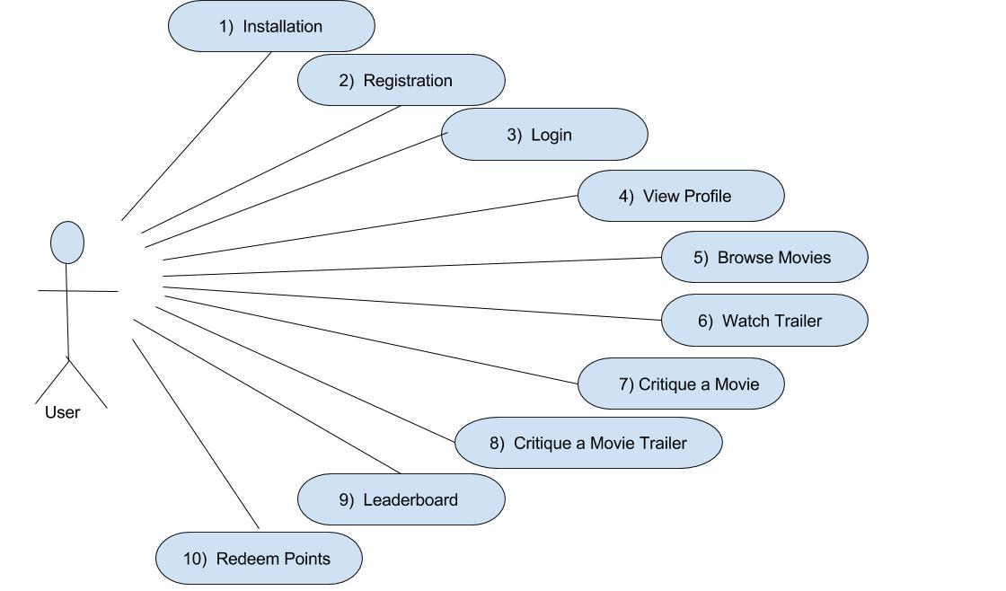

**Glossary**

**Accumulate:** Users will acquire points over time per review given.

**Credentials:** Users are required to login with their email/username and password they selected during the registration process.

**Critique:** Users will offer useful and informative responses and reviews to movie trailers and movies.

**Endorsing:** Users can “like” other user reviews, thus backing the review.

**EULA:** End-User License Agreement

**IAW:** In Accordance With

**Incentivise:** Users will receive points for reviews given and can redeem those points for rewards.

**Leaderboard:** Users will be publicly ranked based on number of reviews given and how many users endorse and back their reviews.

**Redeemable:** Points received for movie reviews can be used to purchase movie tickets and movie theater concessions.

**Store Credits:** Users will use their acquired points to purchase movie tickets and movie theater concessions.

**Terms of Service:** Strict guidelines set forth by the Moo application pertaining to a username, a user’s avatar, and reviews given.

**Uninformative:** A vulgar review deemed unhelpful to users and fellow movie reviewers.